### Comparing the 3 friends

* Friend #1: What if we ask this friend a lot of yes-no questions? We'll always get the wrong answer so all we have to do is do the exact opposite. In this way, the complete liar gives us a lot of information.
* Friend 2: In contrast, the one who lies half of the time doesn't really help us much since we have no idea if we should believe them or not.
* Friend 3: Obviously a truthful one is super-helpful too.

So we conclude that the worst one is this one in the middle.

### The models

In the same way, we'll have our three models.

* Model one is the truthful one which is always correct
* Model two is a random one which is correct roughly half of the time
* Model three is a liar which is always wrong

We'll assign the truthful model a large positive weight, the random model weight of zero since it's useless, and the liar model a large negative weight since we'll do the exact opposite as this model says.

### The math behind this

We want our weight function to be very positive for the truthful models, zero for the useless models, and very negative for the liar models. Let's look at the accuracy :

* The truthful model has accuracy around one
* The random model has an accuracy of around 50 percent
* The liar model is accurate around zero.

So this function will help us check it out:

*y* = *ln*(x / 1 - x) where x is the accuracy.

* It's very negative for values of x close to 0
* It's close to 0 for values around .5
* for example, for 0.5 it's
* *ln*(0.5 / 0.5 ) = *ln*(1) = 0
* It's very positive for values of x close to 1.

There are actually much heavier mathematical reasons for this to be the function but that's outside the scope of this course. Don't worry, for now, about potential division by zero, we'll deal with that in a bit.

We conclude that a great formula for weight is this,

*y* = *ln*(*accuracy / 1 - accuracy* )

### Quiz

So a small quiz, can you find the weights for these three models over here?

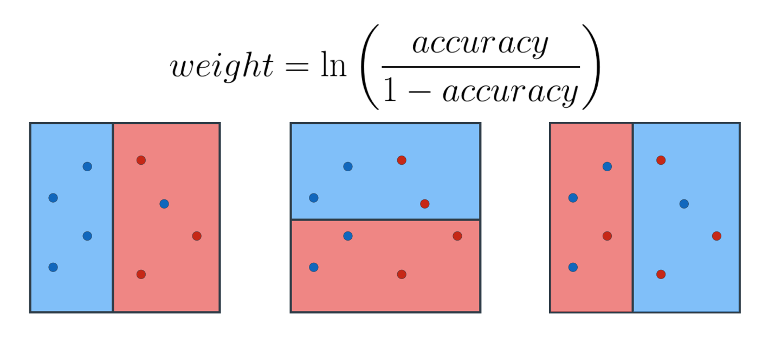

### Weight quiz 1

Calculate the weight of the first model, with 2 significant digits._____________________________________________________

### Weight quiz 2

Calculate the weight of the second model.

_______________________________________________________

### Weight quiz 3

Calculate the weight of the third model, with 2 significant digits._______________________________________________________

| **Model** | **Accuracy** | **Weight** |
| --- | --- | --- |
| Model 1 | 0.75 | ≈ 1.10 |
| Model 2 | 0.5 | 0 |
| Model 3 | 0.5 | 0 |